Bug Report

Description:

Registration with Facebook account is unavailable

Steps to reproduce:

1. Go to [www.sportklub.rs](http://www.sportklub.rs)
2. Click on the Registration button
3. Click on the Facebook button

Test Data:

/

Expected Result:

Ability to log in with Facebook account

Actual Result:

Notification opens at log in Facebook page

Time Stamp:

6/11/2019, Wednesday at 11.17 a.m.

Screenshot:

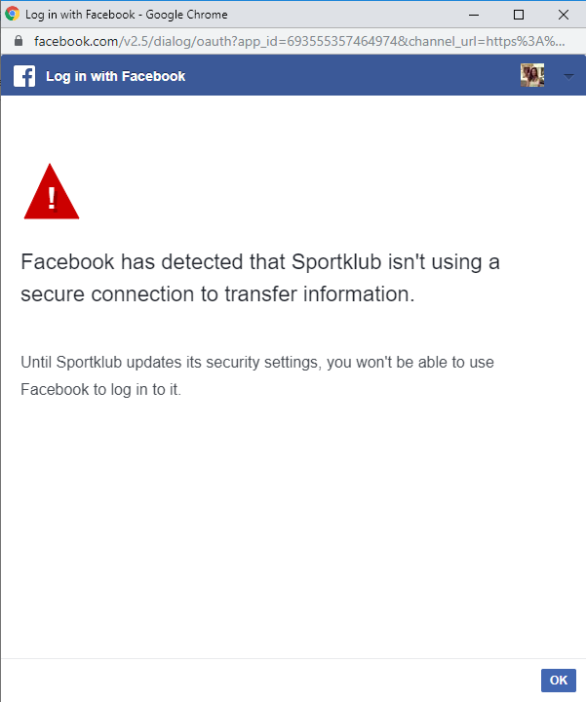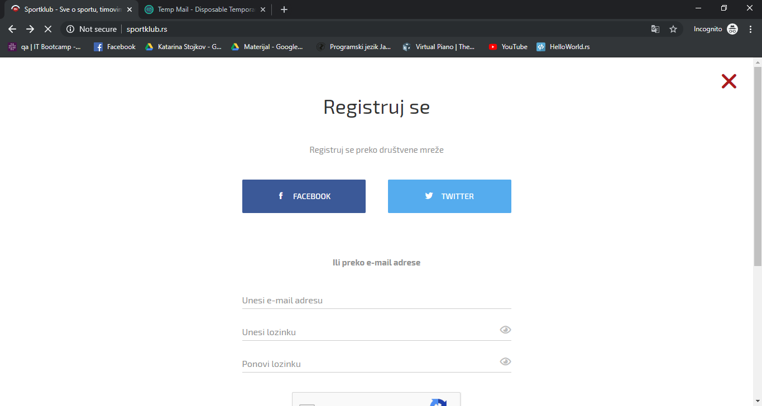

Environment:

Google Chrome Version 78.0.3904.87; Android Version 9

Severity:

Medium

Priority:

Medium